All Saints’ Clooney

Preparation for Baptism

Information Booklet

Thank you for choosing All Saints Clooney Church as the beginning of your child’s journey with God.
Baptism is not simply an isolated ceremony to be carried out for the sake of tradition, it is a sacred and blessed welcoming of your precious child into a wonderful family, the All Saints family.
It is for this reason that we ask that parents bringing children to be baptised are members of All Saints Clooney Church. We also ask that parents and families attend church for at least eight weeks prior to baptism and we hope that indeed you will continue to share in your childs journey through their early years, into Sunday School. It is important that you uphold the promises you make at your childs baptism, to encourage their learning and faith, but you will not be alone in this, we are a church full of families who are delighted to welcome your children into our midst. Each family bringing a child for Baptism will be assigned a personal Baptismal Friend, a member of our congregation who is there for you and your family for any questions you may have after the Baptism, to help and encourage you and to provide a link into our church life for newer families.

There is one body and one Spirit—just as you were called to one hope when you were called—one Lord, one faith, one baptism, one God and Father of all, who is over all and through all and in all.
(Ephesians 4: 4-6)

Introduction

This Booklet has been designed to give advice and offer guidance to anyone considering baptism for their child.

It has been kept as simple as possible while seeking to explain the reasons for baptism, what it involves and what its significance is.

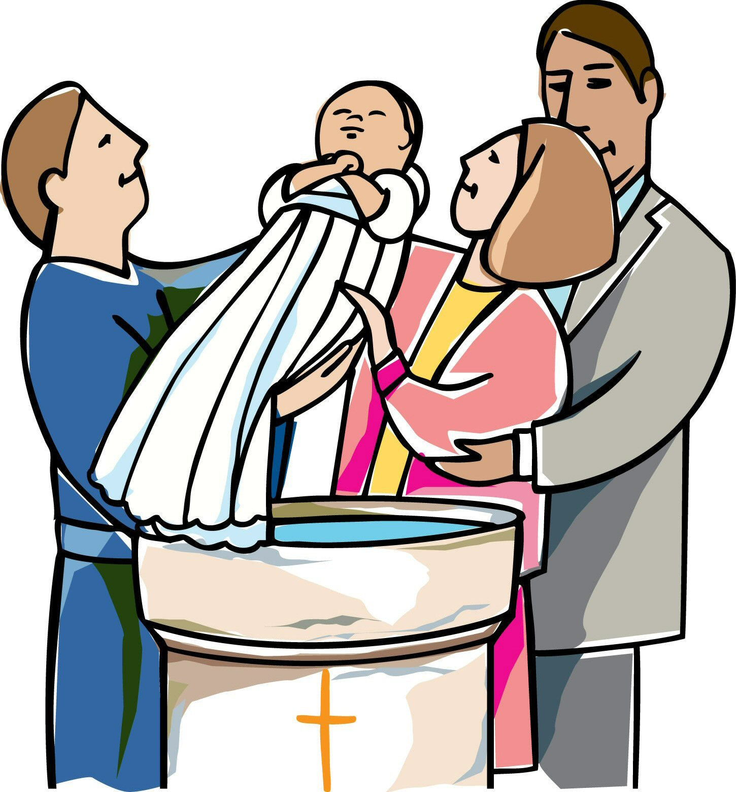
Having read the booklet, please consult the Rector if you wish to proceed with baptism or if you have any questions which require further clarification.

May our God bless you as you begin the nurture and upbringing of
your precious child.

Common views of Baptism

Baptism means many things to many people.

ϖ To some, it is something special which every child should have, whether they belong to the Church or not.

ϖ To some, it means the child will go to heaven.

ϖ To some, it is a ‘passport’ into church life and all that this entails.

ϖ To some, it is a quaint custom to be retained

ϖ To some, it is a response to Gods free gift of eternal life.

ϖ To some, it is a response to Jesus’ command to be baptised. (see Matthew 28:19)

What does it mean to you?

What is Baptism?

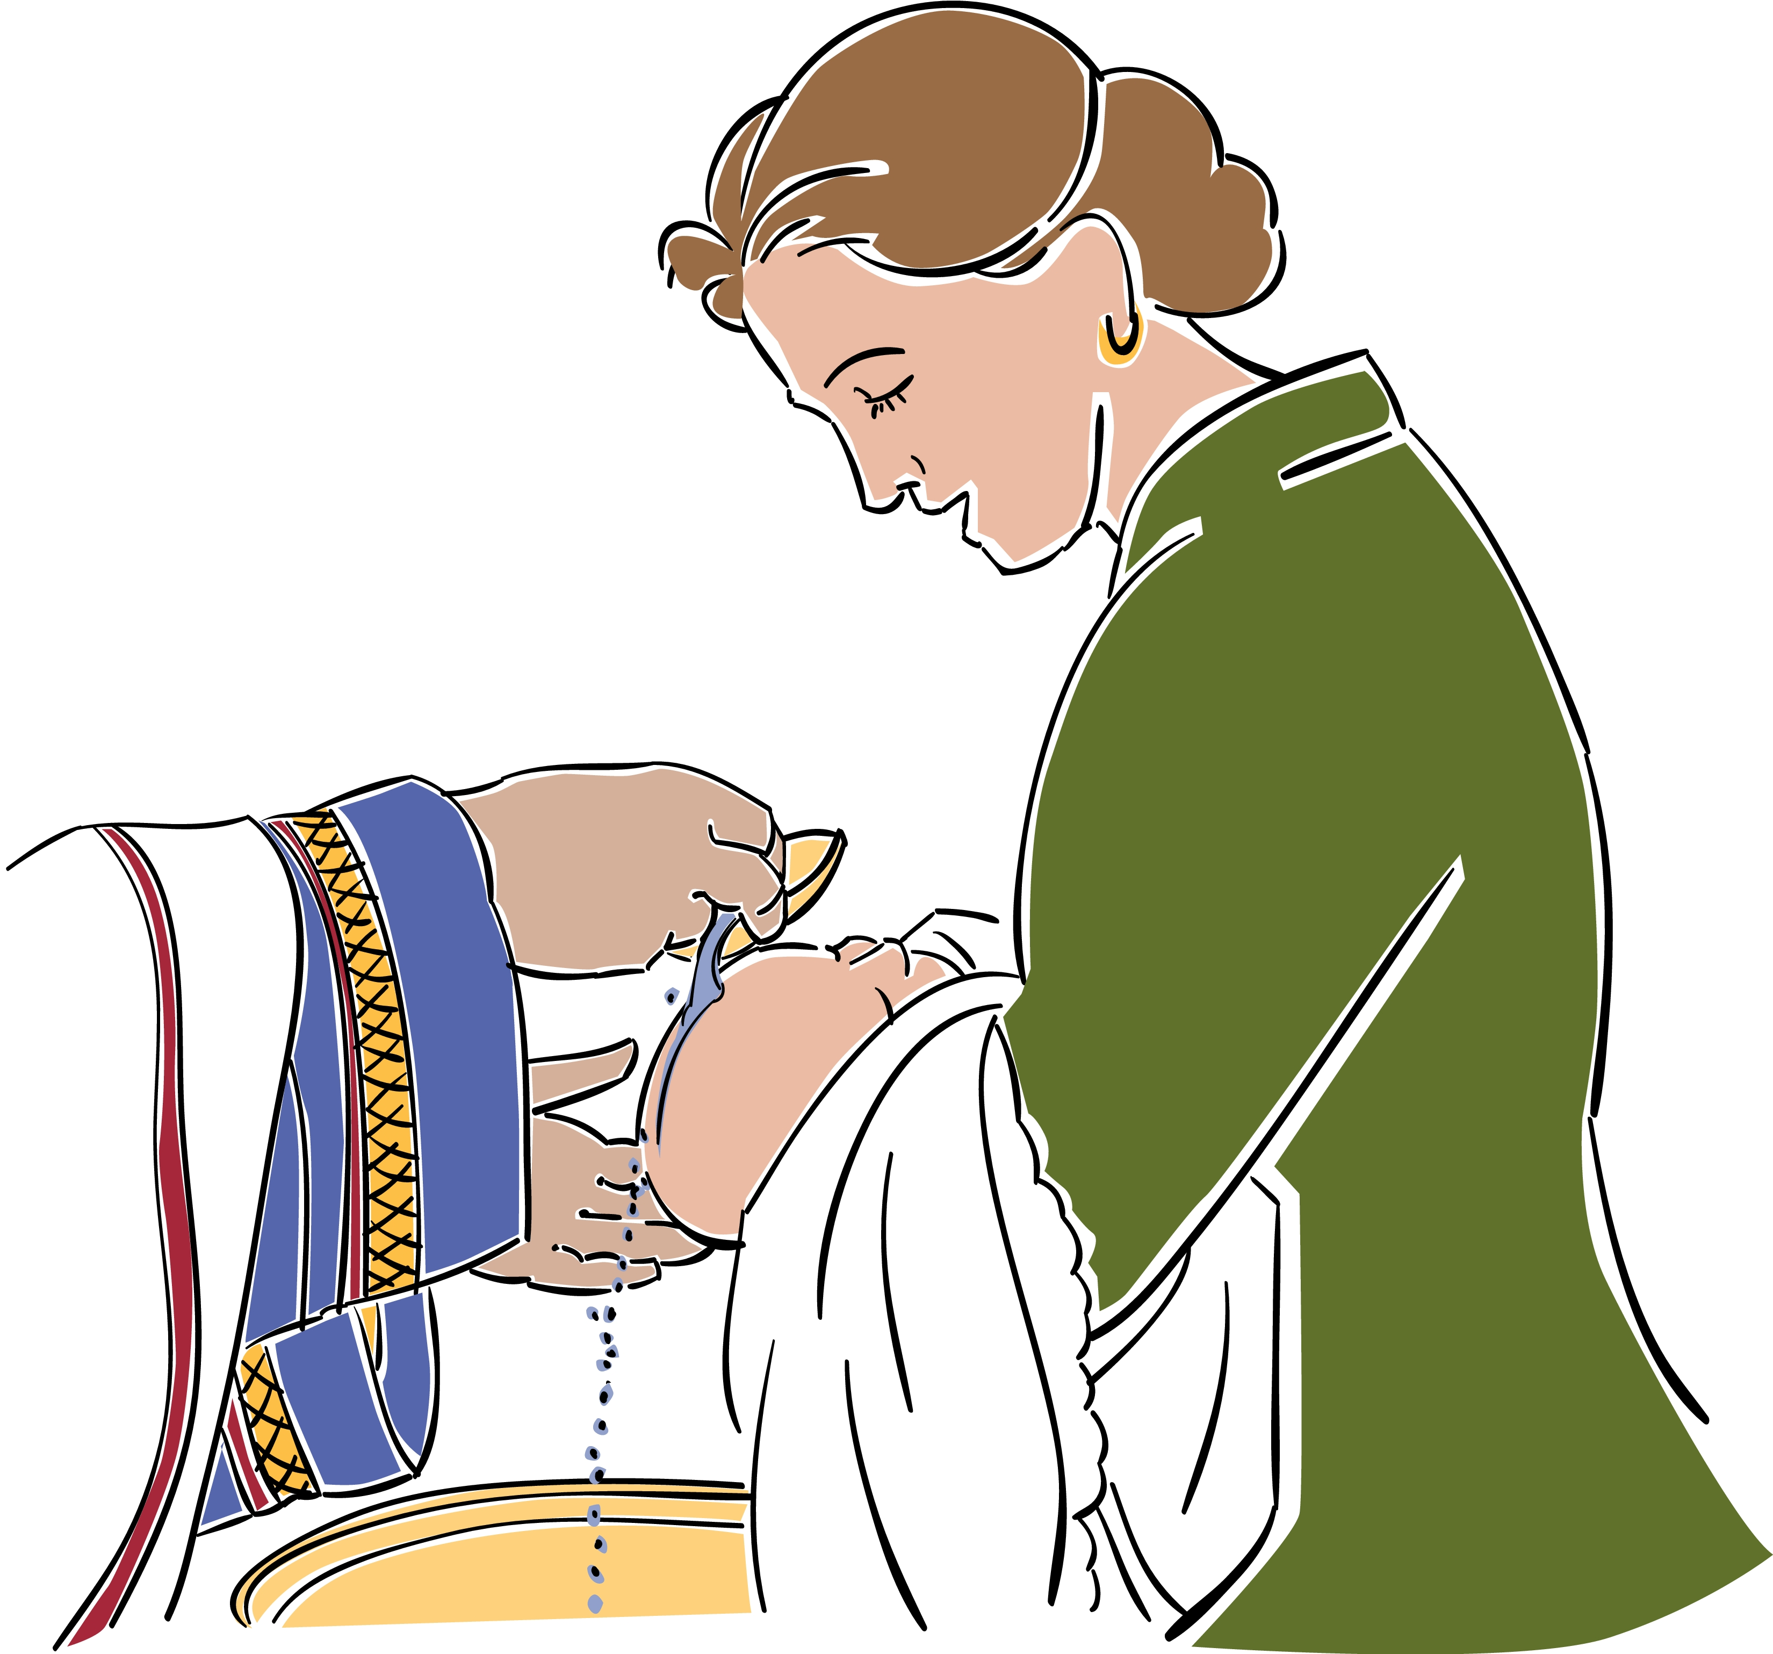
Baptism is your child’s initiation into the Christian Church. Once you are baptised you are a member of the whole worldwide Church of God, not just a member of All Saints’ Clooney in the Church of Ireland.
It is a once only rite, not to be repeated again. Once baptised you cannot be ‘unbaptised’.

Baptism is a means whereby the person to be baptised (or their sponsors) profess their faith in Jesus Christ.

It is a covenant between God and his people.

Firstly
God offers the gift of eternal life and the Holy Spirit through Baptism (Acts 2:38).
Our sins are washed away (Acts 22:16)
we become one with Christ our Lord (Gal 3:27)

Secondly
We, in response, (through faith and in repentance for our wrongdoing) accept his offer. Both parts are necessary for the covenant to be valid.
Baptism without faith and repentance is like having a cheque but never cashing it in. It is of no value.
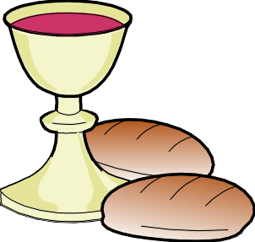
Baptism is one of two sacraments of the Church, the other being Holy Communion.

Baptism is not for everyone. It is for people who believe in God and Jesus Christ as Lord.

Baptism is not a naming ceremony. Your child will already have a name before being baptised.

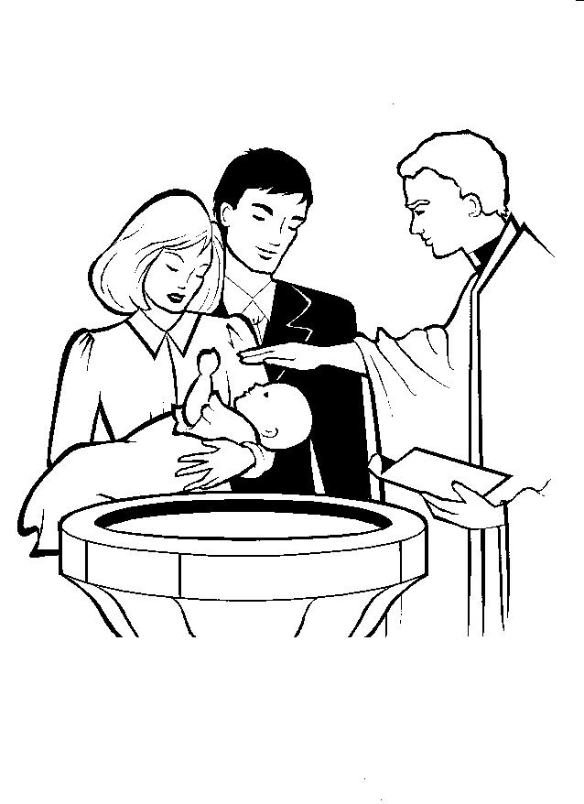
In other words………….Baptism is…..

The beginning of a journey, with God, that should last forever.

Baptism is not……

“some magical act which automatically saves the person being baptised.”

“Baptism is not unconditional. It always requires a response from you.”

“Repentance and faith are a commitment to follow Jesus.”

“Baptism is not a one-off event to be forgotten.”

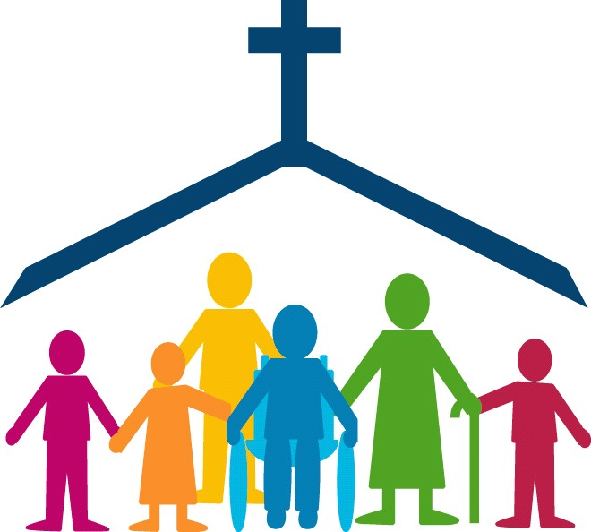

We need to remember our baptism and reclaim the promises made as we celebrate its meaning throughout the church year and for the rest of our lives.”

Before baptism

Reading this Booklet is the beginning of a process that may affect your child for the rest of his/her life.

Your first decision is whether or not to consider baptism for your child.

If your answer is yes, then you should contact the Rector at the address given at the back of this Booklet. He will be happy to talk to you and will answer your questions, attempt to set your mind at ease and explain fully to you the requirements and the consequences of baptism.

If you are considering having Godparents please note Godparents must be baptised themselves.

If your answer is no you may still wish to speak to the Rector regarding your faith and church.
Choosing a date and time

This will be considered carefully with the Rector.

It is normal for baptisms to take place during the main Sunday services.

Why is Baptisms carried out at the main Sunday service?

ϖ Your child is being welcomed into the body of Christ, the Church. This means that the body (in this case the people of All Saints’ ) should be present to welcome your child.

ϖ Baptism is a time for the sponsors and parents to profess their faith. This is a public acclamation not a private statement.
ϖ The congregation have the opportunity to restate their own faith and they promise to support your child and yourselves as you continue in the Christian faith.

ϖ There will usually be one or two other children being baptised at the service so the date has to suit them as well. Baptisms are held on the last Sunday of each month. No exceptions.

During the baptism

These words form part of the pastoral introduction to the service of Holy Baptism.

“Baptism marks the beginning of a journey with God, which continues for the rest of our lives, the first step in response to God’s love. For all involved, particularly the candidates but also parents, Godparents and sponsors, it is a joyful moment when we rejoice in what God has done for us in Christ, making serious promises and declaring the faith.”

Your child will be at the front of the Church along with relatives and friends. The intention would be for your child to remain in Church during the full service, but if difficulties arise then please feel free to slip into the porch until the crisis is over !

Baptism is an occasion to be enjoyed and remembered.

We will all try and keep the atmosphere friendly and relaxed, whilst maintaining a reverence for the occasion.

During the service certain significant things take place which will involve your child, yourselves and the whole congregation.
Presentation

Parents and Godparents will present those to be baptised to the whole congregation and openly accept the responsibilities to bring them up in the life and faith of the Christian Church. They promise, with God’s help, to care for them and help them take their place within the life and worship of Christ’s Church.

Decision

One or other of the parents or Godparents may wish to publicly testify to their life as a follower of Jesus Christ. This is not compulsory but is an opportunity to express openly what Jesus has done for you.

During the decision part of the service, parents and Godparents will be asked some very serious questions before God. These are:
Do you reject the devil and all proud rebellion against God?

Do you renounce the deceit and corruption of evil?

Do you repent of the sins that separate us from God and neighbour?

Do you turn to Christ as Saviour?

Do you submit to Christ as Lord?

Do you come to Christ, the Way, the Truth and the Life?
These questions and the answers you give are the basis upon which your child is brought to baptism.
Belief in God and Jesus Christ as Lord is essential, otherwise baptism is meaningless.

The baptism

During the actual baptism itself, you will be asked if you believe and accept the Christian faith into which your child is to be baptised.

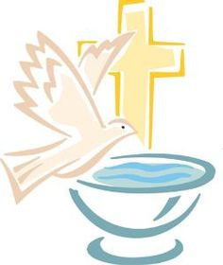
Then everyone will be asked to profess their faith through the words of the Apostles creed, asked via three questions. This is the opportunity for the wider Church (as represented by the congregation in Church) to proclaim Jesus as Lord and stand alongside you.

Your child will then be baptised in the name of the Father, and of the Son, and of the Holy Spirit.

The minister will use a liberal amount of water during the baptism, pouring water over the head of the child.

One reason is that as God’s grace is freely and abundantly given for us, so water is freely used in the baptism. This symbolically represents the complete washing away of sin as we are totally cleansed when we give ourselves over to Jesus.
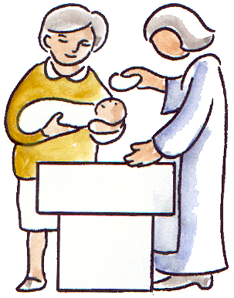
Your child is now received into the Church as a full member.

“All of you who were baptised into Christ have clothed yourselves with Christ” (Galatians 3:27)

“Therefore, if anyone is in Christ, he is a new creation; the old has gone, the new has come!” (2 Corinthians 5:17)

Immediately after the baptism itself the minister will make the sign of the cross on the forehead of your child. You may do likewise. This act symbolises Christ claiming your child as his own, and gives a ‘mark of faith’ to your child to follow for the rest of his/her life. We remember that our journey of faith comes from Christ’s death on the cross and his glorious resurrection from the dead.
After the service

Your child is now a full member of Christ’s Church, but what does this mean?

It means that your child is accepted as a Christian through faith. As you bring up your child in faith and trust in God, and as the whole Church supports and encourages you, so your child will grow in knowledge and love of God.

Your child will receive an inheritance at its baptism. This inheritance is nothing less than a mansion in heaven itself, prepared by Jesus. All that has to happen for this inheritance to be realised is for your child to accept it!

It is like your child receiving a cheque for any amount you can think of. It’s brilliant isn’t it?
But – what if your child couldn’t be bothered going to the bank and cashing it? Imagine the cheque eventually running out of time and becoming worthless. The cheque was written and given with no strings attached. All that is required is a willingness to accept the free gift and cash it in.
So it is with baptism.

God does his part. He provides everything necessary for your child, but it is worthless until your child ‘cashes it in’.

At some stage your child has to accept Gods free gift for himself or herself.

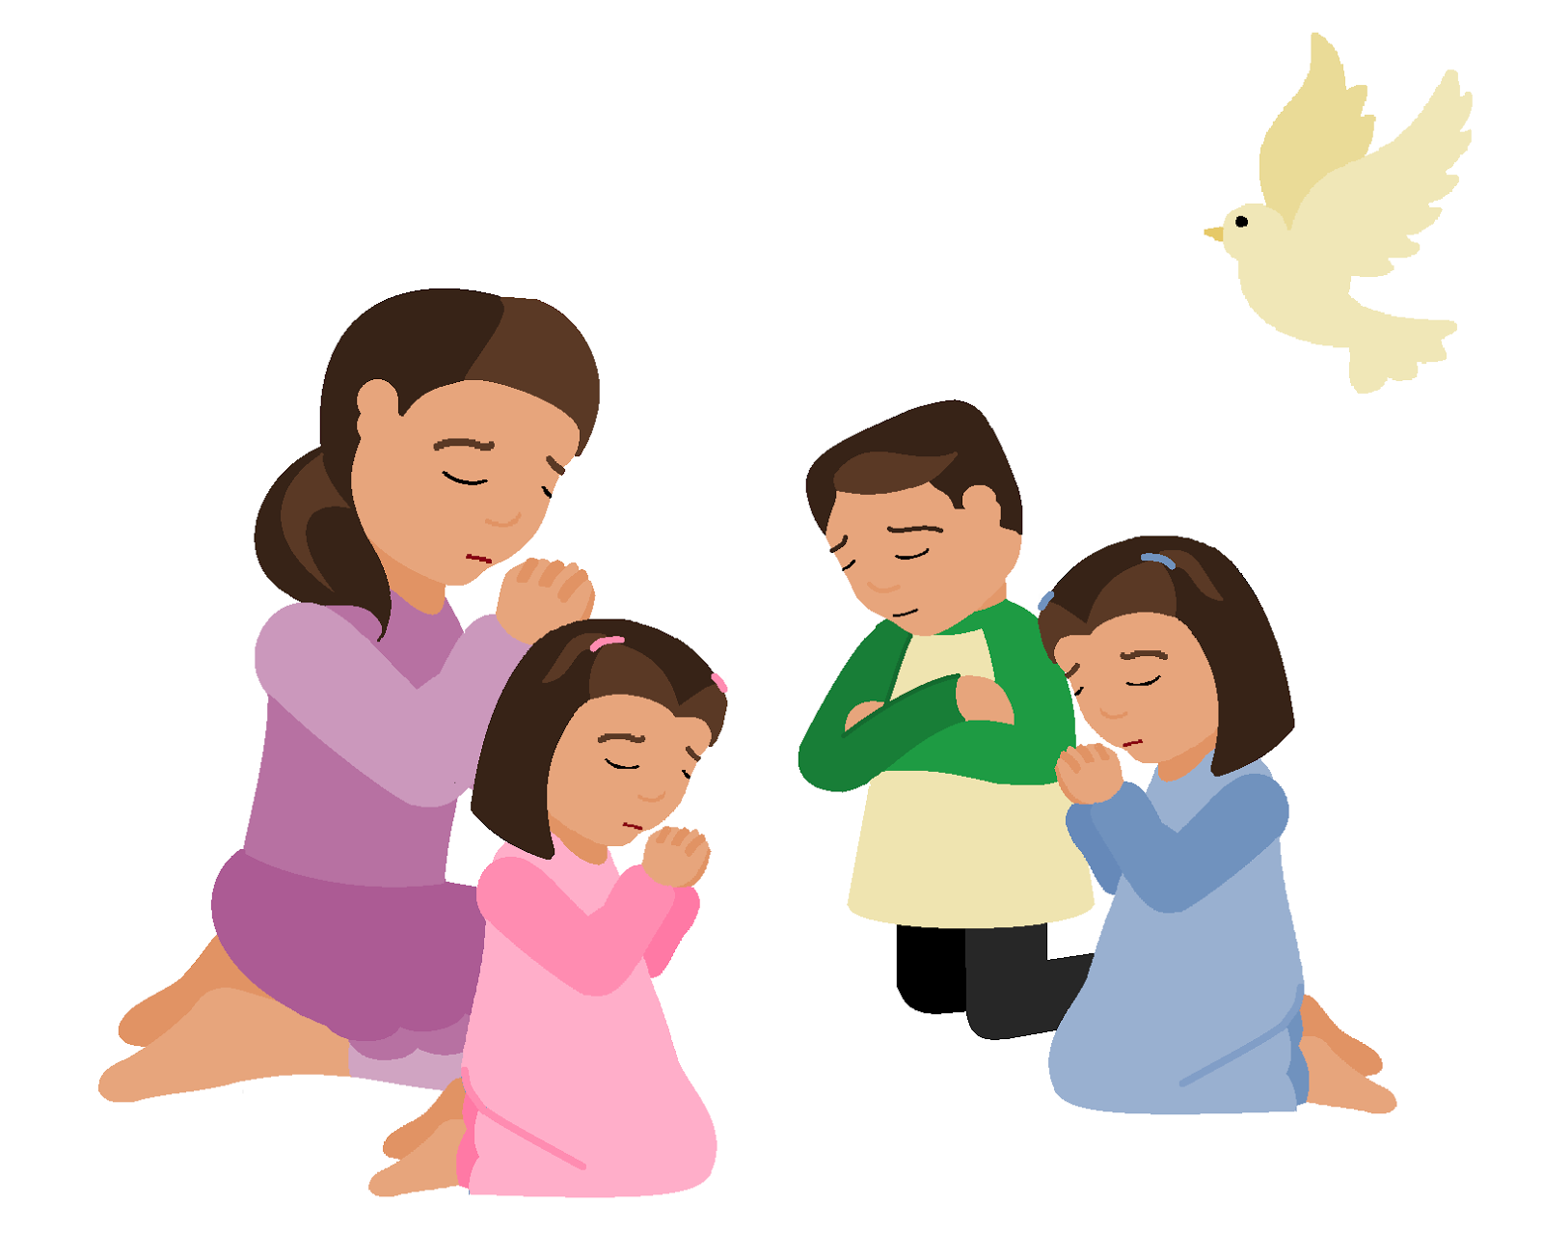
Your life and faith is vital for the nurture and growth of your child.

If you don’t pray….
your child will think prayer is unimportant.

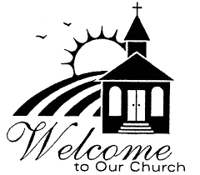
If you never read the bible—your child will think it is irrelevant.

If you don’t attend worship—your child will ask why he/she should.

As you worship God and live a life committed to following Christ so the example you set will be invaluable.
Something more………….You are not alone!!

ϖ The Church offers its full support and prayers throughout your life.

ϖ The congregation in Church are here to help you. We will encourage you in our worship and fellowship and in our prayers.

ϖ We can provide practical help through Sunday School, youth organisations, prayer and bible study groups as well as individual help as required.

ϖ Baptism marks the start of a journey– a journey which lasts a lifetime.

ϖ It will not always be plain sailing but it will be very rewarding if we follow our Lords commands.

ϖ We pray that God will bless this journey for your child and help you to guide and direct him or her along God’s path.

“For I know the plans I have for you,” declares the Lord, “plans to prosper you and not to harm you, plans to give you hope and a future.”
(Jeremiah 29:11)

Practical Issues

Baptism is a joyful occasion. Don’t worry about the baby crying etc. If things get too much, you can slip out for a few minutes as necessary.

You can invite as many friends and relatives as you like to the service.

All books required will be supplied. All you have to remember is to bring your child!

Many families like to record the baptism. We understand this and photographs may be taken before or after (but not during) the Service. Baptism is important and we would not want anything to distract or take away from the occasion.

How much does it cost?

Nothing! But families are encouraged to give a
THANK OFFERING in the envelope provided for the children’s ministry in the church especially the ‘Sunday School’
Next Step

Should you wish to proceed with Baptism for your child then please contact the Rector at the Rectory or at the Parish Office. The numbers are given at the end of the booklet
May God bless you as you think through the issues and come to a decision.

Some final thoughts

The Church, as represented by the parish and people of All Saints’ Clooney, welcomes you and your child.

Baptism offers your child all of God’s grace and an inheritance with him. God’s Spirit will come to your child to help, support, encourage and correct him/her. All of Gods mercy and love is available.

In return, this inheritance is received through faith and a turning away from wrongdoing into a relationship with Jesus Christ, our Lord and Saviour.

Baptism is a once-for-all entry into the worldwide Church of God.

Baptism is not the end. It is the beginning of a new relationship with the creator of the Universe. The journey begins at baptism and continues forever.

“Jesus answered, ‘I am the way and the truth and the life. No one comes to the Father except through me.’” (John 14:6)
Contact

Sarah Cox
Parish Office
Tel. (028) 71349348

(Mon-Thur, 9.30am-1.30pm)
Email
allsaintsclooney@btinternet.com

